Aim: Data Exploration and Preprocessing using Python
Loading and previewing the data
import pandas as pd
import numpy as np

df = pd.read_csv("steam.csv")
# Data preview
df.head()

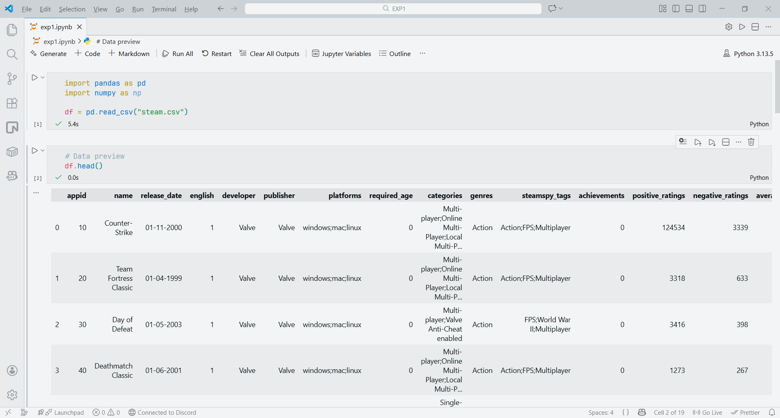

Analysing the data
# Analyzing the structure of the dataset
df.info()
df.shape

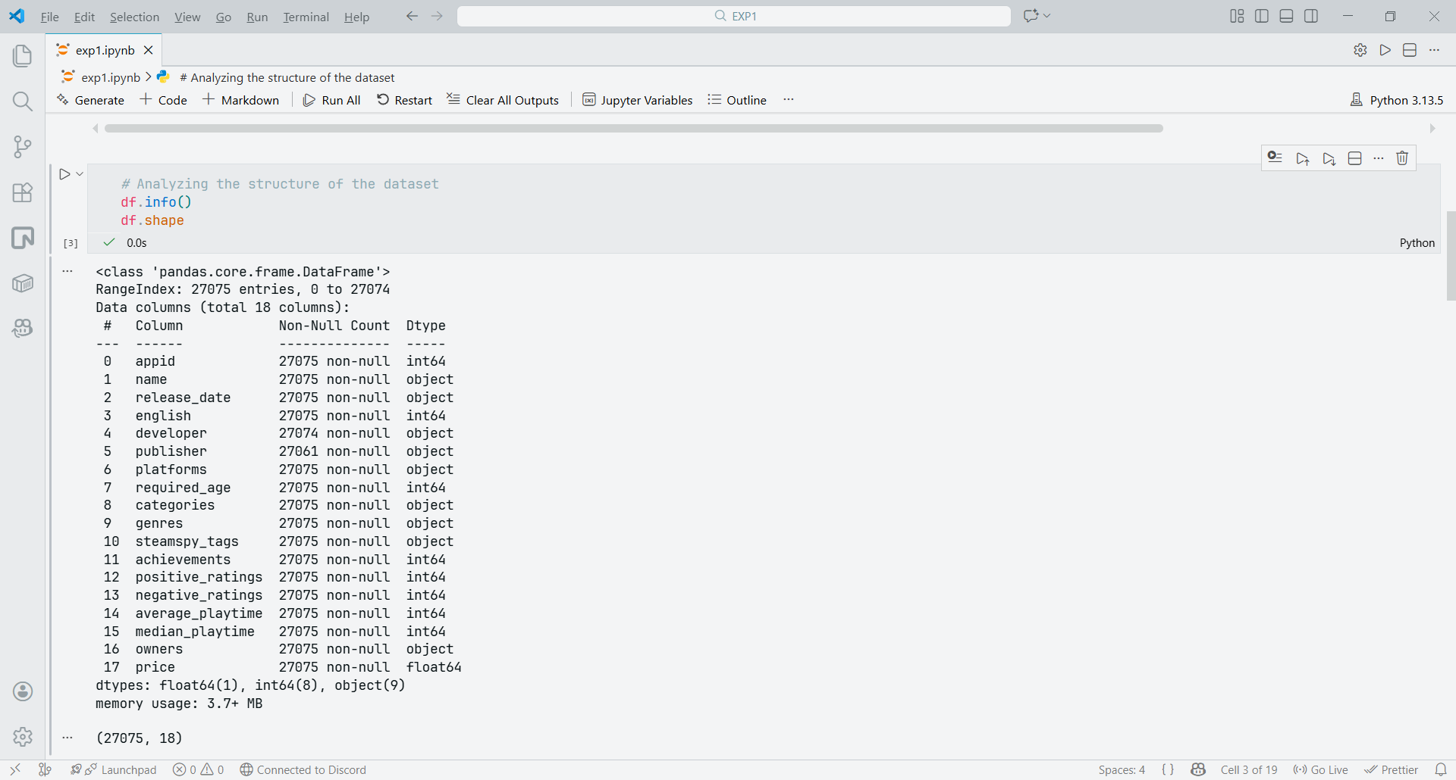

Analysing the data
# Looking for the missing data or cells in the dataset
df.isnull().sum()

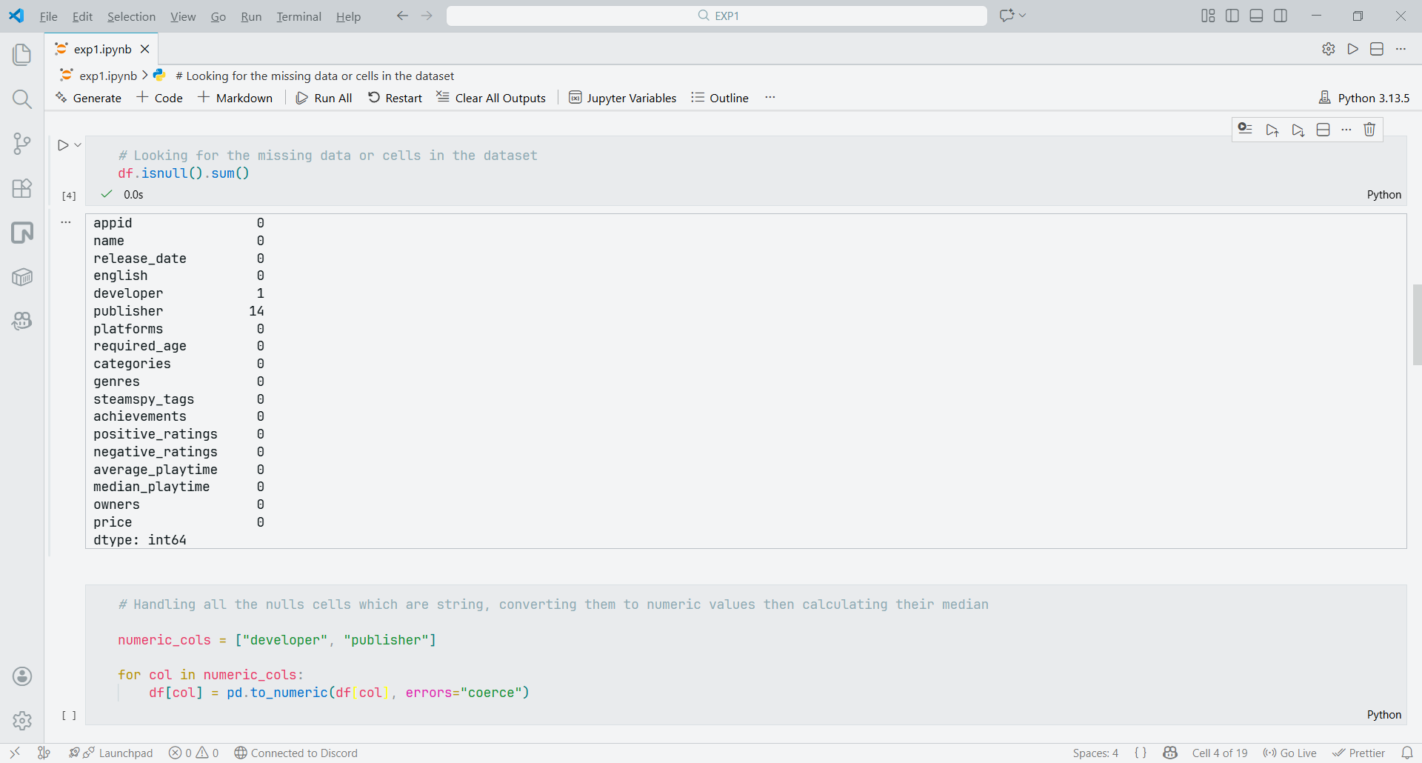

Filling missing fields
# Missing developer means unknown - so filling them with "Anonymous"
df["developer"] = df["developer"].fillna("Unrated")
# Missing publisher means unknown - so filling them with "Anonymous"
df["publisher"] = df["publisher"].fillna("Anonymous")

# Verfying if the data is cleaned
df.isnull().sum()

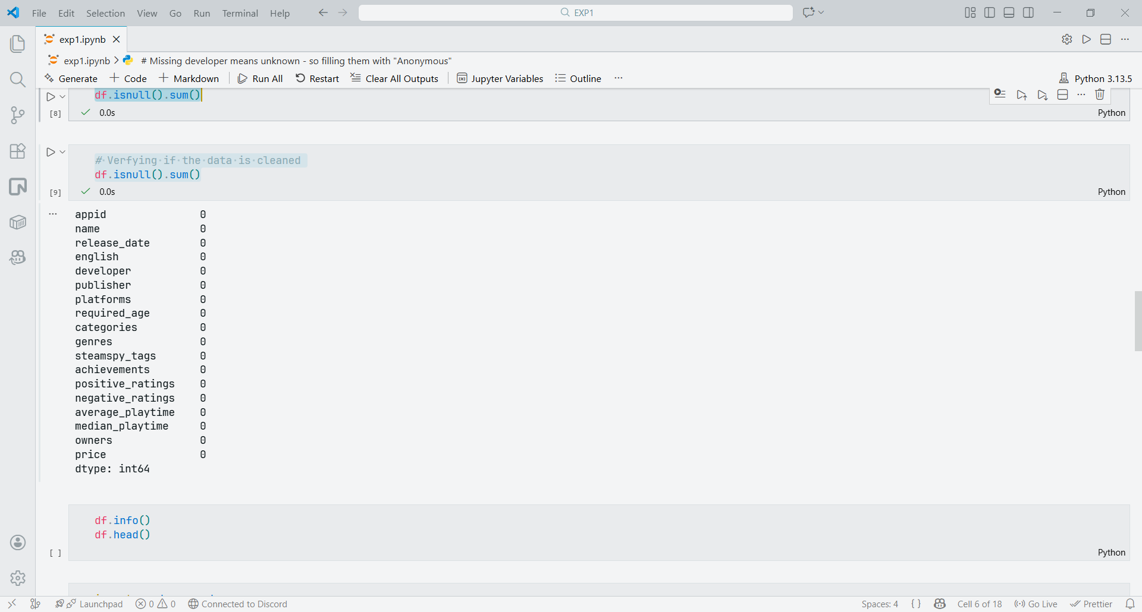

Calculating Outliers
import pandas as pd
import numpy as np

# Create sample Dataset 1
data1 = {'ID': [8456, 1236, 7896, 2541, 7852],
'Value': [78541, 56321, 56324, 74124, 32145]}
df1 = pd.DataFrame(data1)

# Create sample Dataset 2 (with a potential missing value and an outlier)
data2 = {'Score': [88975, 10592, np.nan, 56371, 54789],
'Category': ['A', 'B', 'A', 'B', 'C']}
df2 = pd.DataFrame(data2)
print("Dataset 1:\n", df1)
print("\nDataset 2:\n", df2)

df2['Index_Field'] = df1.index
print("\nDataset 2 with Index Field:\n", df2)

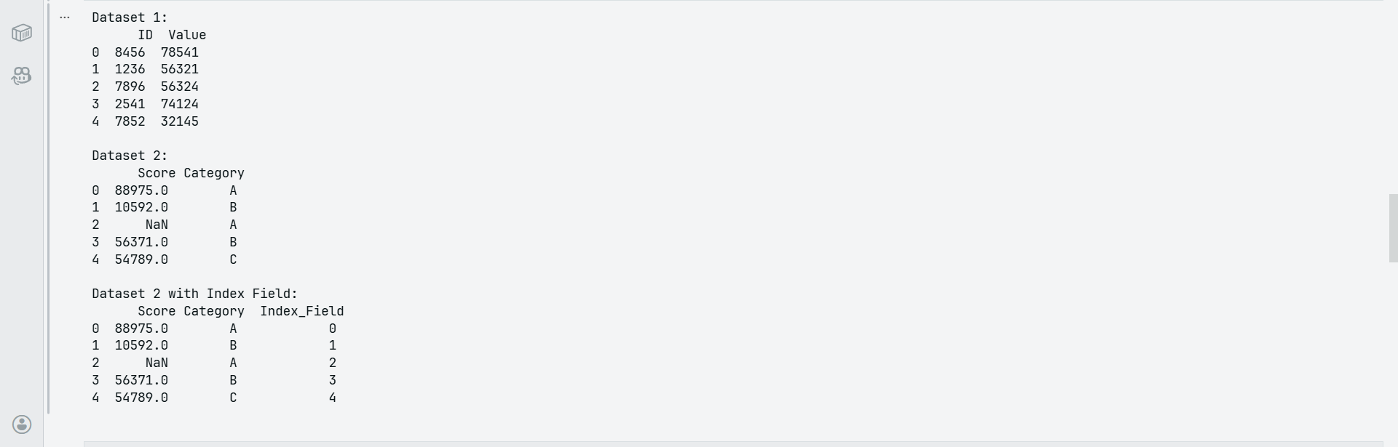

Checking for missing values
missing_values = df2.isnull().sum()
print("\nMissing values in Dataset 2:\n", missing_values)

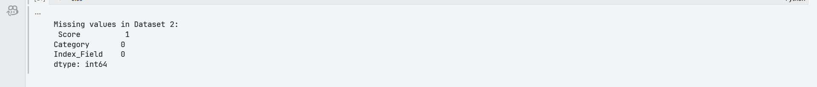
missing_rows = df2[df2['Score'].isnull()]
print("\nRows with missing 'Score' values:\n", missing_rows)

Calculating IQR
# Calculate Q1, Q3, and IQR for the 'Score' column
Q1 = df2['Score'].quantile(0.25)
Q3 = df2['Score'].quantile(0.75)
IQR = Q3 - Q1

# Define bounds for outliers
lower_bound = Q1 - 1.5 * IQR
upper_bound = Q3 + 1.5 * IQR

outliers = df2[(df2['Score'] < lower_bound) | (df2['Score'] > upper_bound)]
print(f"\nRecords identified as outliers in 'Score' field (Lower bound: {lower_bound}, Upper bound: {upper_bound}):\n", outliers)

# Print a listing of the largest values for that field (e.g., top 3 largest)
largest_values = df2.nlargest(3, 'Score')
print("\nTop 3 largest values in 'Score' field:\n", largest_values)

Outliers
